Data Analytics

Module 4 Challenge

**School & Standardised Test Data Analysis Report**

**The School & Standardised Test Data enabled the calculations and analysis as listed:**

* **Local Government Area (LGA) Summary**high-level snapshot of local government area school's key metrics
* **School Summary**key metrics about each school
* **Highest-Performing Schools**by % Overall Passing
* **Lowest-Performing Schools**by % Overall Passing
* **Maths Scores by Year**average maths score for students of each year level (9, 10, 11, 12) at each school
* **Reading Scores by Year**average reading score for students of each year level (9, 10, 11, 12) at each school
* **Scores by School Spending**school performance based on average spending ranges (per student)
* **Scores by School Size school** performance based on school size (small, medium, or large)
* **Scores by School Type** school performance based on the "School Type"

The School Summary provides the School & Standardised Test Data, without presenting any obvious trends. However, further analysis of key datapoint calculations, trends do become clear as depicted below.

**Highest-Performing Schools -** Just over half, 3/5 or 60%, of the top 5 performing schools by % Overall Passing are Independent schools.

**Lowest-Performing Schools -** Nearly all, 4/5 or 80%, of the bottom 5 performing schools by % Overall Passing are Government schools.

**Scores by School Type -** % Overall Passing rate Independent 76.97% Government 70.70%

By analyzing the top 5 and bottom 5 performing schools by % Overall Passing simultaneously, a clear relationship between Standardised Test Performance and School Type can be seen.

Additionally, the trend is strengthened further with the difference in the % Overall Passing rate for Scores by School Type. Independent schools have a 76.97% Overall Passing rate, 6.27% HIGHER than Government schools with a 70.70% Overall Passing rate.

**Conclusion:** Independent schools show positive trends on the % Overall Passing of Standardised Test Data.

**Scores by School Spending**

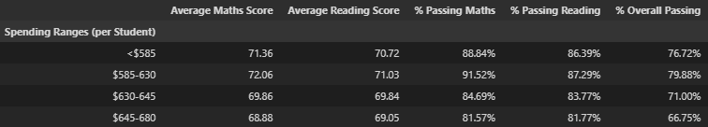The Spending Ranges (per Student) table grouped the schools into 4 expenditure groups.

When ranked in order of performance the analysis showed that schools with an expenditure in the group $585-630 per student are the highest performers with 79.88% Overall Passing performance rate.

The 2nd highest performing expenditure group is <$585 with 76.72% Overall Passing.

Schools in the highest expenditure group $645-680 have a 66.75% Overall Passing performance rate, 13.13% **LOWER** Overall Passing performance rate than the top ranked % Overall Passing expenditure group.

**Conclusion:** Expenditure over $630 per student show negative trends on the % Overall Passing of Standardised Test Data

**Scores by School Size school**

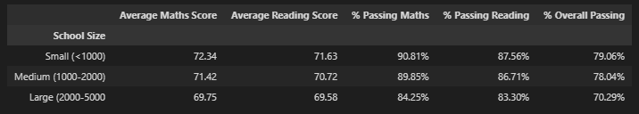The School Size table grouped the schools into 3 student count groups.

When ranked in order of performance the analysis showed that schools in the “Small (<1000)” school size group are the highest performers with a 79.06% Overall Passing performance rate.

The 2nd highest performing school size group “Medium (1000-2000) with 78.04% Overall Passing. Only 1.02% less than the “Small” school size.

Schools in the “Large (2000-5000)” school size group have a 70.29% Overall Passing performance rate, 8.77% **LOWER** Overall Passing performance rate than best % Overall Passing performing school size “Small”.

**Conclusion:** Schools with a student count greater than 2000 show a negative trend on the % Overall Passing of Standardised Test Data.

**Bottom 5 schools – student count 17,335 (44.26% os LGA student count)**

**1st gov 4635 $652**

3rd gov 4761 $652

**Summary:**

The data provided included a total of 15 Schools and 2 “School Types”.

The 15 schools comprised of 8 Independent and 7 Government Schools.

Independent schools show a positive trend on the % Overall Passing of Standardised Test Data.

Expenditure over $630 per student shows a negative trend on the % Overall Passing of Standardised Test Data.

Student count greater than 2000 shows a negative trend on the % Overall Passing of Standardised Test Data.

**Bottom 5 schools - ALL 2000+**

**Bottom 5 schools - total student count 17,335 (44.26% of LGA student count)**

**Top 5 schools - total student count 14,101 (36.00% of LGA student count)**

Key statistical differences between Independent and Government school’s can be seen in primarily in:

Budget (per student)

7/8 Independent & 1/7 Government schools budget is <$630

0/8 Independent & 3/7 Government schools budget is $645-680

School Size / Student Count 2000+

7/7 Government

1/8 Independent (AND lowest Independent school performance)

**Recommendations**

Budget (per student) < $630

School Size / Student Count <2000